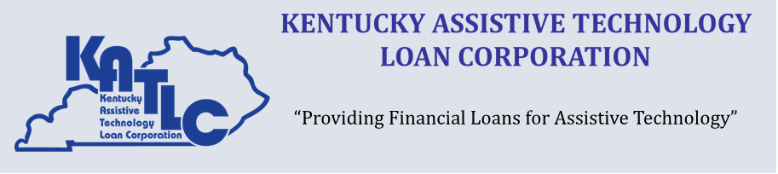

Annual Report

State Fiscal Year
July 1, 2022 – June 30, 2023

2023 State Fiscal Year
In state fiscal year 2023, the Kentucky Assistive Technology Loan Corporation (KATLC) continues to locate a lending partner to provide assistive technology loans to individuals with disabilities. Staff reached out to multiple financial lending institutions, as well as banking and lending professional organizations. Until a financial lending institution is in place KATLC can not provide assistive technology loans.

Individuals who are requesting loans are referred to other potential resources, if applicable and their contact information has been maintained to provide information when a financial lending partner is in place.

Annual Financial Report July 1, 2022 to June 30, 2023

Income
State General Fund Allotment | $ 75,000.00
Interest Income on Deposits for Guarantees | $ 57,508.88
Total Program Income | $132,508.88
Expenses
Operating Expenses | $26,908.55
Default (1) | $ 215.95
Total Program Expenses | $27,124.50
Accounts Available for Loan Guarantees
As of June 30, 2023
Checking Account | $ 42,367.61
Investments | $1,733,278.59
Total Available for Loan Guarantees | $1,775,646.20

1

KATLC Board of Directors

Leah Dozer Louisville
Katie Gilliam London
Keith Hosey Louisville
Carrissa Johnson Murray
Kenneth Jones Louisville
Emily Kimbell Frankfort
Chris Lindsey Frankfort

2
.

