

Annual Report
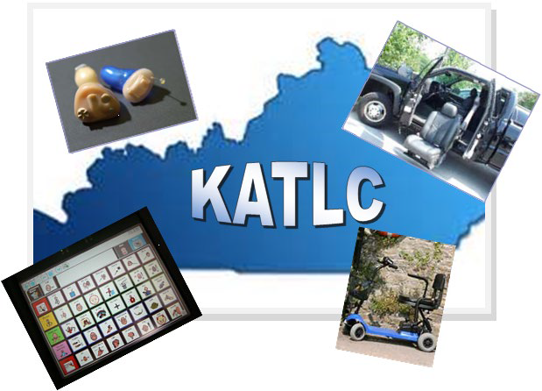

July 1, 2023 – June 30, 2024

2024 State Fiscal Year
In fiscal year 2024, the Kentucky Assistive Technology Loan Corporation (KATLC) received 79 applications and approved 55 applications for loans. The total amount loaned for assistive technology devices was $290,998 at a zero percent interest rate. Applications denied were for such reasons as a high debt to income ratio, late or past due payments on current financial obligations, and recent bankruptcies.
From 2000 to 2023, KATLC has received 2,332 applications, with 1,343 being approved for loans. The total amount loaned was $10,958,071. These loans have allowed individuals with disabilities to increase their independence and to establish, improve or maintain their credit reports at the three credit reporting bureaus.

Assistive Technology Devices
Hearing aids were the most requested assistive technology devices in state fiscal year 2024. The remaining loans were for single items such as a scooter, stair lift, sound generator and a vibration device.

Below is a breakdown of the approved assistive technology devices:

Types of Assistive Technology | # of Approved Devices | $ Amount of Loans | % of Loans
Hearing Aids | 51 | $278,404.00 | 92%
Scooter | 1 | $3,297.00 | 2%
Sound Generator | 1 | $3,200.00 | 2%
Stair Lift | 1 | $3,200.00 | 2%
Vibration Device | 1 | $2,897.00 | 2%
Total | 55 | $290,998.00 | 100%

KATLC entered into an agreement with the Appalachian Assistive Technology Loan Fund to provide zero percent interest loans for assistive technology between the amounts of $100 to $7,000.
KATLC continued to attempt to locate a lending partner for the higher dollar amount loans. Discussions have been held with various financial institutions but have proven to be unsuccessful.
KATLC participated in exhibits at the following events: Shelby County Transition Fair, Madison County Transition Fair, Southeast South Central Kentucky Transition Fair, Exceptional Children, Senior Expo, KY Speech Hearing Language Association, Possibilities Expo and BRIDGES across the Commonwealth representing a diversity of disability groups. KATLC staff also provided presentations on the program to individuals with disabilities and services providers as requested throughout the year.
1

Annual Financial Report July 1, 2023 to June 30, 2024

Income
State General Fund Allotment | $ 75,000.00
Interest Income on Deposits for Guarantees | $ 84,127.46
Total Program Income | $159,127.46
Expenses
Operating Expenses | $ 41,170.25
Total Program Expenses | $ 41,170.25
Accounts Available for Loan Guarantees
As of June 30, 2024
Checking Account | $ 41,770.96
Investments | $1,830,065.27
Total Available for Loan Guarantees | $1,871,836.10

Summary of Accounts
Number of Current Outstanding Loans | 55
$ Amount of Outstanding Loans | $290,998.00
$ Amount of Outstanding Loan Balances | $279,184.87

2

Counties with Received Applications

Adair | 1 | Knott | 1
Boone | 1 | Livingston | 3
Caldwell | 1 | Lyon | 1
Calloway | 11 | Lyon | 1
Carlisle | 1 | Marshall | 12
Crittenden | 1 | McCracken | 18
Daviess | 1 | Meade | 1
Fayette | 1 | Nelson | 2
Franklin | 1 | Owen | 1
Fulton | 1 | Perry | 1
Graves | 9 | Trigg | 1
Jefferson | 5 | Whitley | 2
Johnson | 1

Counties with Approved Applications

Boone | 1 | Livingston | 3
Caldwell | 1 | Lyon | 1
Calloway | 10 | Marshall | 3
Carlisle | 1 | McCracken | 16
Crittenden | 1 | Nelson | 2
Daviess | 1 | Perry | 1
Fulton | 1 | Trigg | 1
Graves | 8 | Whitley | 2
Knott | 1

3

KATLC Board of Directors

Leah Dozer Louisville
Keith Hosey Louisville
Carrissa Johnson Murray
Kenneth Jones Louisville
Emily Kimbell Frankfort
Chris Lindsey Frankfort
Shari “George” Polur Louisville

The Kentucky Assistive Technology Loan Corporation does not discriminate on the basis of race, color, national origin, sex, disability, age, religion or marital status in employment, or provision of services and provides, upon request, reasonable accommodations including auxiliary aides and services necessary to afford individuals with disabilities an equal opportunity to participate in all program activities.

4

